ASSIGNMENT 2 --- Web Development --- Jurgen Xhafaj

1. 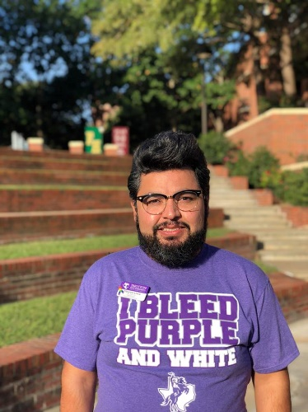**Personas for Madonn’**

**Tiburcio Lince (Turbo)** ~ The classy student (Male, in his late 20’s)

(source: https://www.tarleton.edu/diversity/_contact_info/Tiburcio-Lince-1---Edited.jpg)

Main Objectives: purchase breakfast quickly

pay easily

Main Concern: being able to order today’s special at 6 am when he wakes up

Quote: “Because having rose milk isn't extra enough, you have to serve it in your

fancy set. Also, šimšek biscuits will add to the extra experience”

Turbo has a taste for authentic foreign food, with an emphasis on Italian and French food. He is tired of going to Pastafina and getting pretty much the same thing as literally every other restaurant in the city. When he sees those brioches and biscotti with hazelnuts on the breakfast menu, he is sure he has found his new love, which is Madonn’!

Generally, he will be okay with various options of Italian beverages at Madonn’, but he DEFINITELY needs his cappuccino and macchiato, as well as the original Espresso all’ Italiana, preferably of the trademark “Don Caffe”. That said, his typical ordering times are 6-7:30am, so he can order breakfast online and then pick it up or just have it ready when he walks in Madonn’. If the website is down in the morning for whatever reason, there is a high chance that Turbo will have a headache, and get grumpy, as well as post a status on Facebook saying “Madonn’ , why did you do this to me?” As long as the website is up and running, Turbo will be a very loyal customer to Madonn’.

As a graduate student at TSU, and a student worker with International Students’ office, he is rather familiar with other places in the world (besides US and Mexico, where he is originally from). If Turbo decides to go on a date, he will choose no other option rather than Madonn’ once we earn his trust with our breakfast menu. Being rather tech savvy, he would love to see a mobile app, but he will also be happy to navigate our website and order a meal easily.

**Mr. and Mrs. Jones** ~ the local aristocrats (M 40 & F 35)

(https://i.ytimg.com/vi/ZdSK4x8w08w/maxresdefault.jpg)

Main Objective: reserve a table for 2 (or 4, if they

bring the kids) for lunch or dinner

Main Concern: is the website going to show available

spots accurately

finding contact information easily on the website (online forms / phone numbers)

Quote: Please make sure you have Marsala Wine from Sicilia for us two, and Dr. Pepper

for the kids; I also think Lizzie also wants some of those Modica chocolate bars.

Their income level is certainly higher than Turbo’s, but they are not as tech savvy, so they will always order online using their laptop, and quite possibly using Internet Explorer. Somewhere along the line in Mr. Jones’ family, there were some relatives in Sicily, so he has a thing for their culture, hence the preference for Marsala Wine. This couple has lunch at a restaurant every day, since they can afford it, and leads a rather luxurious lifestyle, so getting their business would be a big plus. They also bring the kids for dinner at least twice a week.

In a typical Saturday, they would ask for a table for four, and they plan to dine in from 8pm to around 10pm. To make a reservation, they will use the “reserve a table” button and enter the information on their food and beverage preferences, as well as any other special requests they might have. Considering their rather wide work network, they will often bring a coworker or two with them to have lunch with.

Being rather well-off means being able to afford going to Fort Worth or even Dallas to have a meal with the family, so as long as we cater to their demands, we shall secure ourselves a very loyal couple of customers who can spread the word.

**Claus Kellerman** ~ the faculty member (M 45)

(source: <http://i.ytimg.com/vi/TGnWup1y3SY/mqdefault.jpg>)

Main Objective: have lunch with a group of 4-5 students

order tables for ~20 faculty members

Main Concern: needs nice pictures on the website to

convince other faculty members at the Dept of Psychology to join the party

Quote: “Ecstasy and bliss could easily be followed by disappointment and frustration.”

With that kind of quote in mind, Mr. Kellerman reminds us of the impact that a negative experience can have to our customer base. That said, Mr. Kellerman, as well as other people in Psychology department have a tradition for going out to pizza places as a department. That translates into a lot of additional income for Madonn’ and potentially an exponential growth of the customer base. Their preferences are classic, pepperoni, and Carbonara pizza, but they are also willing to try out new types of pizza. They want to see the pizzas before trying them out, and there will be an extensive menu with pictures on the Madonn’ website.

Claus and his colleagues are able to easily order and navigate online, and they have seen a lot of websites, so our website will not have broken links or a lack of pictures. The age range of members of psychology department varies wildly (20s-60s), so serving buffalo chicken pizza to everybody is a no-no. Diversity is key. This is extra information, but some of these faculty members would love to advertise our place in class, so randomly giving them gift cards to hand out to students for accomplishments will also help build a positive image.

P.S. The photo above is taken from a lecture from Mr. Kellerman while he dives into a very heated argument on the use of certain words that are generally frowned upon.

1. **Concept model**

This has been attached as a PowerPoint file, but here is a screenshot of it.

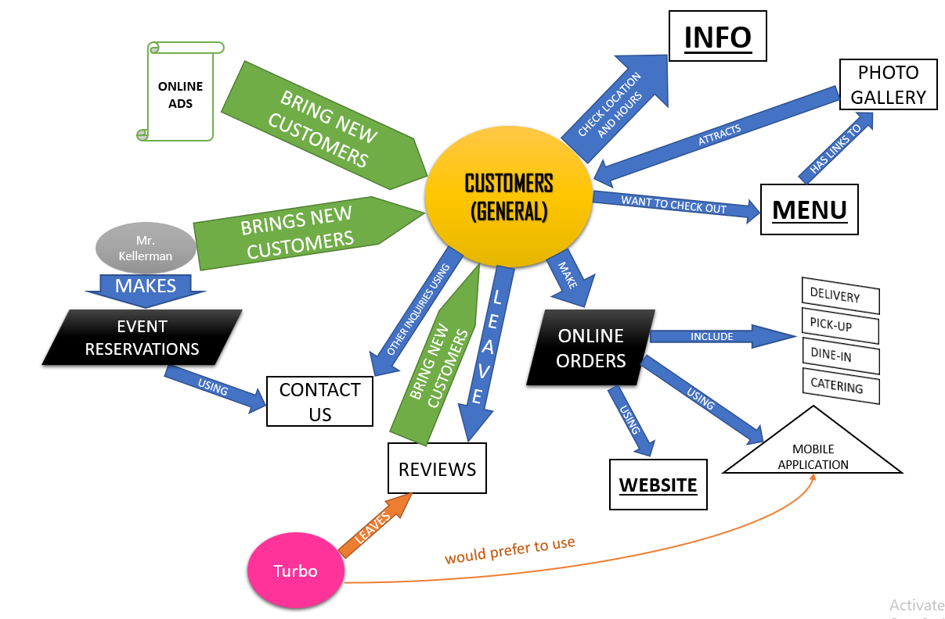

Below, I have made a prioritized list of requirements:

Phase 1

1. HOME (photo, hours, location)
2. CONTACT US (phone numbers, online contact form)
3. ORDER (different types of orders)
4. MENU (breakfast, lunch, dinner, catering)
5. GALLERY (food, activities)

Phase 2

1. Reviews
2. User accounts
3. Social Media plug-ins
4. About us
5. Today’s Special
6. **Site Map**

I have attached a PDF, but here is a PNG version of it.

Link: <https://www.gloomaps.com/D7GifmEbaw>

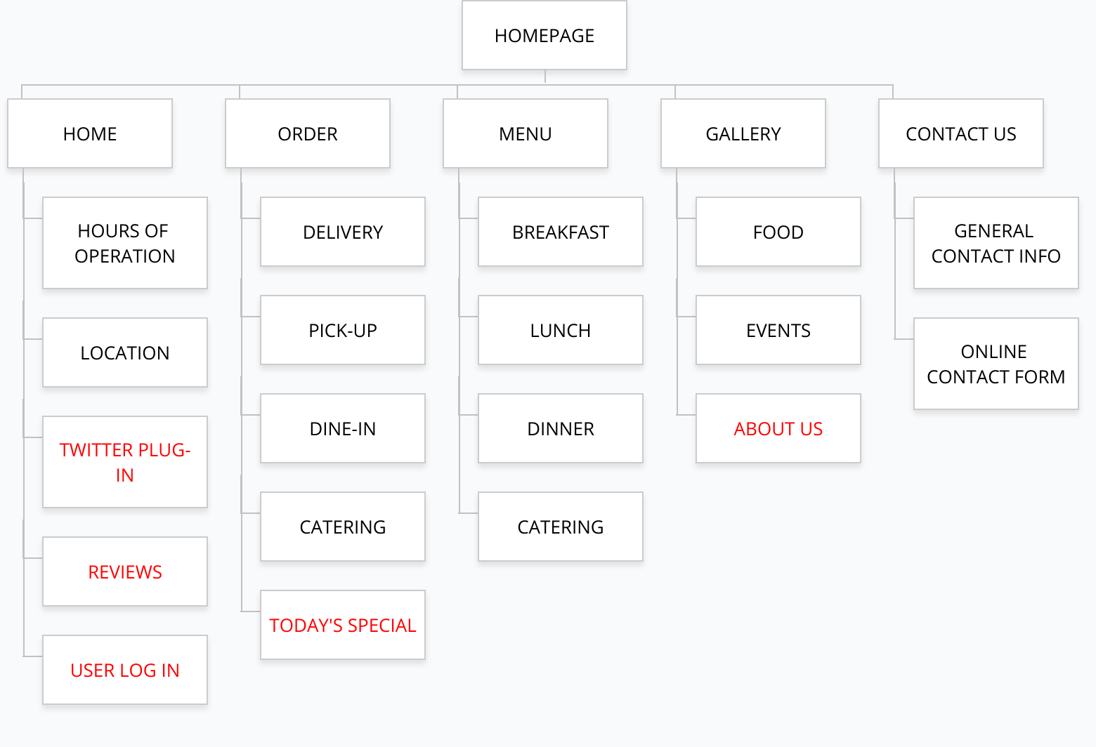 Credits go to GLOOMAPS.COM for their free tool.

**Words on black are from phase 1.**  **Words on red belong to phase 2.**

1. **Flowchart for customer action**

Turbo would like to order some coffee, brioche, and biscotti for his breakfast, delivered to his office, and he goes to the website to make the order. Below is a flowchart that shows the procedure. Credits to Draw.io for the free tool that helped me make the flowchart. PDF is attached too.

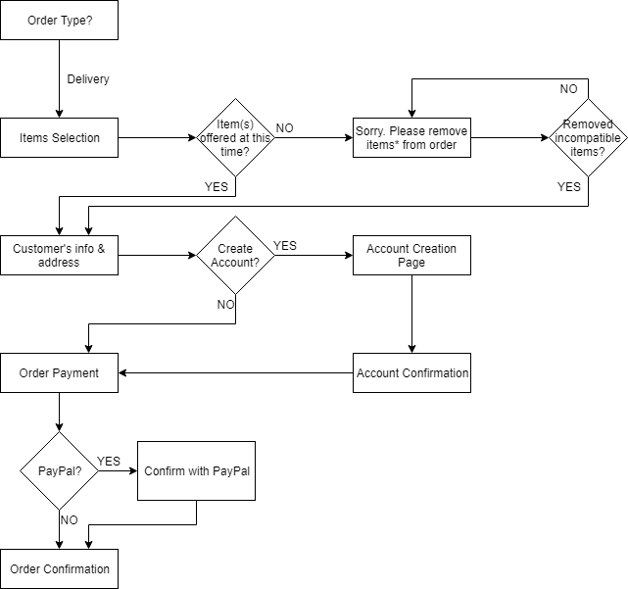

1. **Wireframes**

Below I present the wireframes for main homepage (link same as main-home), gallery (main-gallery), the Food page from Gallery (main-gallery-food), and the Contact Us page (main-about_us). Attached are the respective PDF’s. I have written some explanations (or options for drop-down menus) in parenthesis in these wireframes.

HOME

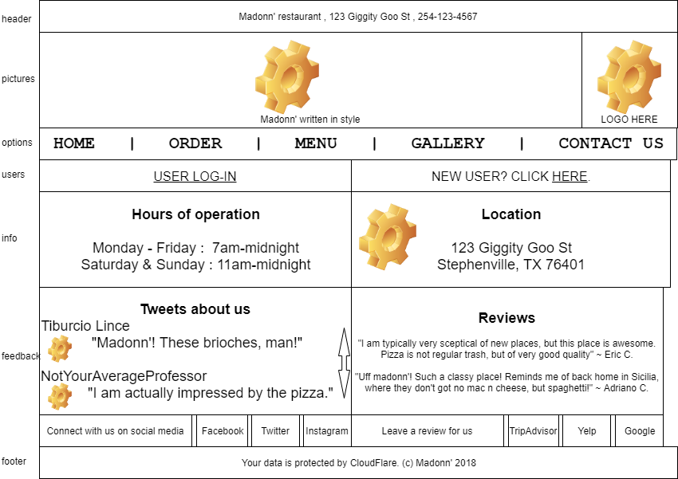

GALLERY

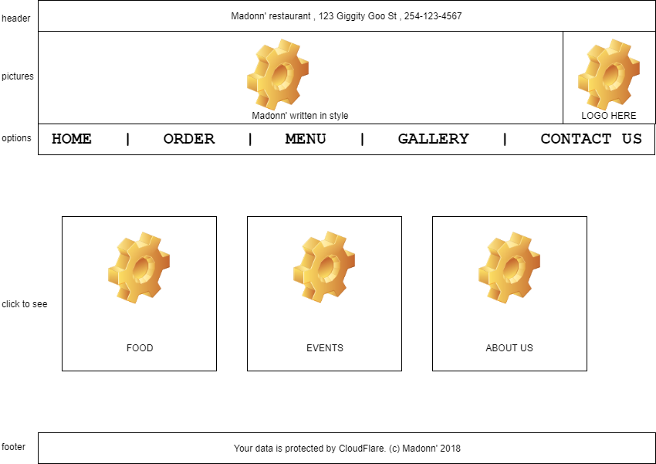

GALLERY – FOOD

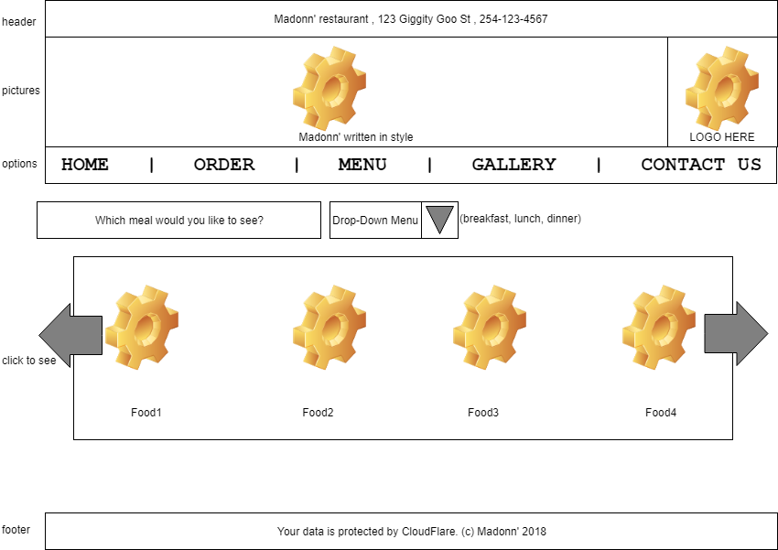

CONTACT US

